Lab 8: Normalization Part Two

1. ER Diagram

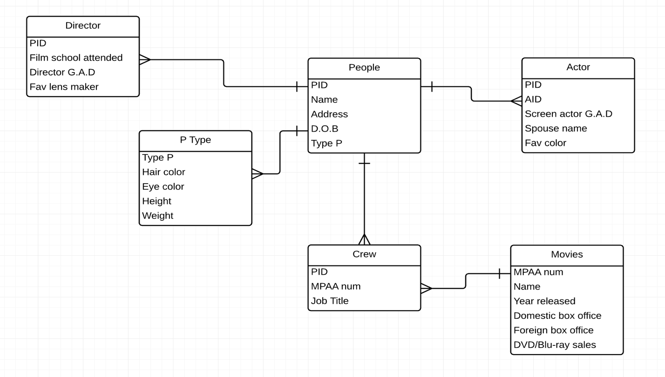

create table if not exists People(

PID INT not null,

Name varchar (30),

Address varchar (30),

BirthDate int not null,

Type_P varchar (30),

primary key (PID)

);

create table if not exists Director(

PID INT not null,

Film_School_Attended varchar (30),

Director_GAD varchar (30),

Fav_lens_Maker varchar (30),

primary key (PID)

);

create table if not exists Actor(

PID INT not null,

AID INT NOT NULL,

Screen_Actor_gad varchar (30),

Spouse_name varchar (30),

Fav_color varchar (30),

primary key (PID)

);

create table if not exists P_Type(

Type_P INT not null,

Hair_color varchar (30),

Eye_color varchar (30),

Height varchar (30),

Weight varchar (30),

primary key (Type_P)

);

create table if not exists Crew(

PID INT not null,

MPAA INT not null,

Job_Title varchar (30),

primary key (PID)

);

create table if not exists Movies(

MPAA INT not null,

Name varchar (30),

Year_released INT not null,

Domestic_box_office INT not null,

Foreign_box_office INT not null,

DVD_Blu_ray INT not null,

primary key (MPAA)

);

1. FD:

**For Director**

PID – Name, Film school attended, Director G.A.D, Fav lens maker

**For People**

PID – Name, Address, D.O.B, Type P

**For Actor**

PID – Name, AID, Screen Actor G.A.D, Spouse name, Fav color

**For P Type**

Type P – Hair color, eye color, height, weight

**For Crew**

PID, MPAA – Job title

**For Movies**

MPAA – Name, Year released, domestic box office, foreign box office, DVD/Blu-ray sale

1. Select name

From actor.a

Inner join director d on d.pid = c.pid

Inner join crew c on c.pid = p.pid

Inner join people p on p.pid = a.pid

Where a.name = “Keenu Reeves”